We’re building a machine-learning model for a Data Science for Social Good course project, tied to UN SDG 4 (Quality Education), specifically target 4.1 (access to education) and 4.5 (eliminating disparities, including for children with disabilities).
Research question: Among children aged 5–16 in Pakistan, can we predict whether a child is out of school (never enrolled or dropped out) using household poverty indicators, legal identity documentation, disability status, and demographic/geographic characteristics? And does the model work equally well for girls, children with disabilities, and rural children, or does it systematically miss some of these groups?
The data is from ASER 2025 (Annual Status of Education Report), a large household survey of children across Pakistan’s provinces. The original raw file had 183,854 child records; after cleaning (restricting to ages 5–16 and valid enrollment status), we have 161,803 rows, each one representing a single child.
Files to use:
- aser2025_training.csv — the actual dataset to train on. Use this one.
- feature_manifest.json — a machine-readable summary of which columns are the target, which are model features, which are the ID/group/weight columns. Load this in your script so you don’t have to hardcode column names.
- data_dictionary.csv — plain-English definition of every variable.
- ITA_ASER2025_Coding_Manual.xlsx — the original survey codebook, in case you want to see how a variable was originally coded before we derived our version of it.
- encoding_log.txt — the exact log from the script that built the training file: what was one-hot encoded, what was dropped, and why. Useful if you need to justify a modeling decision in the writeup.
- subgroup_counts.csv — sample sizes (positives/negatives) for each subgroup (gender, area, disability, province). You’ll need this for the fairness/error-cost discussion — it flags which subgroups have enough data to trust and which are too small.
- attrition.csv — shows how the raw 183,854 rows became 161,803 after cleaning. Just for your reference; nothing left to do here.

The target variable
out_of_school — this is what the model predicts.
- 1 = the child is NOT currently in school (either never enrolled, or enrolled before and dropped out)
- 0 = the child is currently enrolled in school
This is imbalanced: only 13.2% of children (21,288 of 161,803) are out of school. This matters a lot for how you set up your train/test split and cross-validation (see below) — always use stratified splitting so both classes are represented proportionally in every fold.
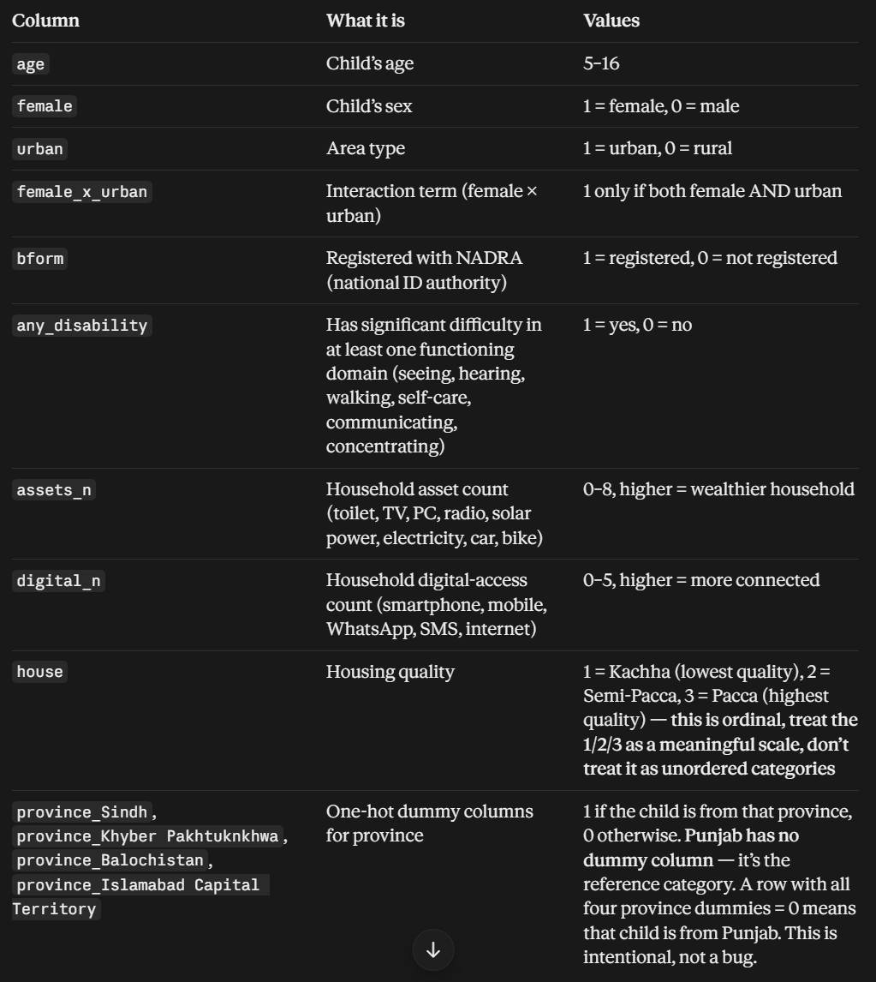
These columns are already fully prepared — don’t re-encode, re-scale, or drop any of them unless you have a specific reason and explain it. Province is the only nominal categorical in the whole dataset and it’s already one-hot encoded for you.

Why these specific variables — the hypotheses they test
Milestone 2 set up 5 formal hypotheses. Each one maps to a specific variable in this dataset, and your model’s coefficients (for logistic regression) or feature importances (for the tree-based model) should be read against these:
- Poverty (assets_n): H0 = asset index has no association with out-of-school odds. H1 = higher asset count lowers the odds. Look at the sign and significance of the assets_n coefficient/importance.
- Legal identity (bform): H0 = B-form registration unrelated to odds. H1 = unregistered children have higher odds of being out of school.
- Disability (any_disability): H0 = no association. H1 = children with a disability have higher odds.
- Gender × area (female_x_urban): H0 = the interaction has no effect. H1 = the gender gap in out-of-school odds differs between rural and urban areas. You need to look at this interaction term specifically, not just female and urban separately.
- Feature value (model comparison): H0 = adding assets_n, bform, any_disability (and the other controls) to a bare-bones demographic model (just age, female, urban) gives no improvement in AUC. H1 = it does improve AUC. To test this, you’ll need to fit one model using only age, female, urban, and a second model using all 13 features, then compare their ROC-AUC. This is a required comparison, not optional — it directly supports H5.
age, house, digital_n, and the province dummies are controls — background variables that account for other explanations, not variables the hypotheses are specifically about, but they should stay in your main (“full”) model.

Columns that are NOT features — don’t feed these into the model
- cid — row ID only. Never use as a predictor.
- district — this is critical. Don’t use this as a feature either, but DO use it to set up your cross-validation. Many children in this dataset come from the same district, and a plain random train/test split would let the model “cheat” by seeing children from the same district in both train and test. Use grouped cross-validation (in scikit-learn: StratifiedGroupKFold, grouping by district), not plain KFold or train_test_split without groups. This is required for the rubric’s “leakage-free cross-validation” requirement.
- weight — the ASER survey sampling weight. Not a model feature. It’s included in case you want to report a weighted version of your prevalence/metrics as a robustness check (e.g., “13.2% unweighted vs. X% weighted out-of-school rate”), but it is not required for the core modeling task. If in doubt, just don’t use it and mention in your writeup that unweighted estimates were used.

What the rubric (Milestone 3) needs from you
- A naive baseline (e.g., majority-class classifier — given the 13.2% imbalance, this baseline would just predict “enrolled” for everyone and still get ~87% accuracy, which is exactly why accuracy alone is a misleading metric here — lean on recall/F1/ROC-AUC).
- At least 2 real models — logistic regression and a decision tree (or KNN) are natural choices and match what’s in data_dictionary.csv’s binary/ordinal structure well. Justify your choice briefly (e.g., “logistic regression for interpretable coefficients tied to our hypotheses; decision tree/random forest to capture nonlinear interactions like H4’s gender-by-area effect”).
- Stratified train/test split or stratified grouped CV, because of the 13.2% imbalance — always pass the target to stratify= and group by district.
- Hyperparameter tuning — e.g., regularization strength (C) for logistic regression, or max_depth/min_samples_leaf for the tree.
- Metrics: accuracy, precision, recall, specificity, F1, ROC-AUC, plus confusion matrices.
- Asymmetric error-cost analysis — this is a required section. In plain terms for this project:
  - False negative (model says “in school” but child is actually out of school) = a child who needs an outreach/enrollment intervention is missed entirely. This is generally the more costly error for an education-policy use case.
  - False positive (model says “out of school” but child is actually enrolled) = an outreach visit, or a scholarship/stipend slot, gets spent on a child who didn’t need it.
  - Report how the confusion matrix changes if you shift the classification threshold to weight recall more heavily (e.g., accept more false positives to catch more true positives), and discuss which threshold you’d recommend for a real deployment.
- Feature importance / driver analysis — rank the 13 features by importance (Gini importance for the tree, standardized coefficients or odds ratios for logistic regression) and connect the top drivers back to the 5 hypotheses above.
- A short Milestone 4 roadmap note — mention that the subgroup breakdowns in subgroup_counts.csv set up the planned fairness audit (checking whether the model’s recall/precision differ meaningfully for girls vs. boys, rural vs. urban, and children with vs. without disabilities), and flag any subgroup in that file with too few cases to draw reliable conclusions from.

Reminder!
There are zero missing values in this dataset (confirmed and documented), so you shouldn’t need an imputation step. If your code ever produces unexpected NaNs after merging or subsetting, that’s a bug to chase down, not expected behavior.

